Dashboard Layout
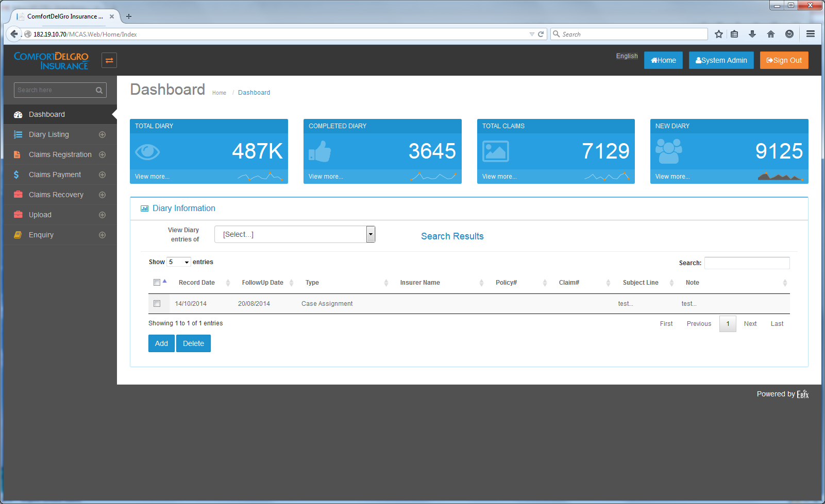
Changes Required:
Singapore (9 Jan 2015): Please ignore all greyed out text below.
The Dashboard is to be configurable for 2 different groups of users. Each group will be able to configure what they want to view on the Dashboard. Each group is allowed access to the following grids:
2 Groups of Users –
- Claim Officers
  - Tasks
  - Diaries
- Supervisors and Claim Officers with FAL
  - Tasks
  - Diaries
  - Mandate Requests
  - Payment Requests
- To display Five Sections: Tasks, Diary, Reassigned Diary, Escalation Diary, Mandate Approval (for Supervisor Group), Payment Approval (for Supervisor Group only)
[Varun 24 Dec. 14]
- We are already having listing functionality of diaries in dashboard screen.
- Do we need to over write this screen functionality with new screen details or just change columns of existing screen and put it under diary section?
Is user able to change the type of data to be displayed in display sections? i.e. Task section change into Payment made for the month.
[Varun 24 Dec. 14]

- Can we put expand / Collapse and Hide functionality for each section as a solution of user customization as per their needs?

Can user track the following so as to assist them in meeting their KPI
- Monthly no. of TPPD/TPBI claims settled.
- Monthly amount paid for TPPD/TPBI Claims, including amount in payment requests pending approval,
- Monthly amount recovered for Recovery Claims
- Or any other type of indicators to assist them in meeting their KPI.
[Varun 24 Dec. 14]

- We need to discuss these requirements in meeting for more understanding as below mentioned tables of sections required do not cover above mentioned KPIs points.
- To display Highlighted Colors for each entries - yellow/green when it is 3 days before Action Due Date and Red when the current date is past the Action Due date.
[Varun 24 Dec. 14]
- Colouring functionality can be provided as per currently running functionality in Task screen under claim registration screen.
- Please check and give confirmation for the same.
- To have sorting for each Column.
[Varun 24 Dec. 14]
- yes
- The possibility for users to rearrange the five sections by moving the section up or down
[Varun 24 Dec. 14]
- yes
- To have five blue boxes to provide overview of the number of items – have options to display e.g. Total Number, Number of Tasks due in 30 Days?
Is the number of different displayed sections at any one time in the dashboard capped at 5? If the number of different sections is not capped at 5, what is the maximum number of different sections allowable?
[Varun 24 Dec. 14]
- Please provide UI details to display five boxes having totals .

[EBIX Singapore -20 January 2015]
Under the Dashboard, the layout should be a dropdown to show the list of sections that can be viewed by user. Upon selecting one… the screen will refresh to show the outstanding items.
Suggested Layout:
Select Section To View: <<Dropdown>>

Column Headers:
Tasks:
S/No. | Claim No. | Claimant Name | Action Due | Close Date | Modified Date | Prompt Details | Action
 |  |  |  |  |  |  | << Select >>
Note: Clicking Select will bring user to the Task Screen of the particular Claim No.

Diary:
S/No. | Claim No. | Claimant Name | Diary Description | Created By | Estimated Completion Date | Action
 |  |  |  |  |  | << Select >>
[India Ebix response]
- Do we need to exclude reassigned diaries , because there is a separate section for reassigned ?

Reassigned Diary:
S/No. | Claim No. | Claimant Name | Diary Description | Created By | Previous CO In-Charge | Estimated Completion Date | Reassigned By | Action
 |  |  |  |  |  |  |  | << Select >>

[India Ebix response]

- Please provide for which user group we need to show re-assigned diary section?
- Do we need to show all diaries which has been reassigned in this reassigned list?
- Ex:
  - If D1 dairy has been reassigned to user B , then if user b will login then D1 diary will be list under this list?
[Singapore EBIX Response]
- What do we mean by separate section for reassigned? This Dashboard Change may replace the whole Diary Listing Section. I will check with CDGI on whether they still want the Diary Listing Section.
- We will have access rights and assign rights for Super Admin to decide which group would like to see what. We just need to have the different Diary and Task Sections to be displayed for Super Admin to select?
- We only show reassigned items that belong to the individual user ID unless the group is of Supervisor because they have the authority to reassign on behalf of the Claim Officers so they will need to see every item.
- Yes. User B will get to see the Reassigned Diary Task upon login.

[India Ebix response 14 Jan., 15]

- Please provide UI layout details of super admin user access for customization of dashboard screen.
- Reassigned diary section means, section given on dashboard.
- Please discuss point 3 , what information we need to provide to supervisor user ?
- It Will be good if you can give us a group wise list of having “to be displayed” information.

[Ebix Singapore 16 January 2015]
UI Layout under Group Access Rights:
Dashboard
<< checkbox >> Tasks | << checkbox >>Diaries | Mandate Request | Payment Request
 | << To Include Personal Diary Items, Reassigned Diary Items & Escalated Diary Items for User to select >>  By default, the above are not selected and user must check any of the section. | << To Show Mandate Requests made, Mandate Approval Requests >> Note: System needs to validate that user has FAL assigned when the Mandate Approval is selected | << To Show Payment Requests made, Payment Approval Requests >> Note: System needs to validate that user has FAL assigned when the Payment Approval is selected

Escalation Diary:
S/No. | Claim No. | Claimant Name | Diary Description | Created By | Estimated Completion Date | Action
 |  |  |  |  |  | << Select >>
[India Ebix response]

- Please provide for which user group we need to show escalation diary section?
- How to we mark a diary “escalation diary” in application?
- From which screen values will come in this section?

[Singapore EBIX Response on 13 Jan 2015]
- Based on the earlier understanding, escalation is to the Supervisor Group.
- There is a section in the Diary Task with the Label “Escalation To” and “Escalation – Yes/No”
- The Created Diary Task will be displayed for the Escalated Individual.

[India Ebix response 14 Jan., 15]

- Ok

Mandate Approval:
S/No. | Claim No. | Claimant Name | Claim Type | Mandate Request Date | Total Mandate Amount Requested | Action
 |  |  |  |  |  | << Select >>

[India Ebix response]

- We are having a process of co approval and supervisor approval on mandate screen , please let us know from which section we need to show records in mandate approval section?

[Singapore EBIX Response on 13 Jan 2015]
- This is from the Mandate Screen… when User creates a OD/PD/BI Claim and inputs some reserves, the system will automatically flow these claims to the Mandate Screen for user to choose if they need to request for Mandate, so when User creates a Mandate Request and chose a Supervisor for approval, the system will automatically display the entry under the Dashboard.

[India Ebix response 14 Jan., 15]
- As per business flow can you give us details of group wise user display information on mandate approval section.
[Ebix Singapore 16 January 2015]
- Do not understand what is required.

Payment Approval:
S/No. | Claim No. | Claimant Name | Claim Type | Payment Request Date | Total Payment Amount Requested | Action
 |  |  |  |  |  | << Select >>

[India Ebix response]
- Please provide functionality of payment screen fields.
- Let us know, from where total payment amount requested will be fetched?
[Singapore EBIX Response on 13 Jan 2015]
- When a Mandate has been created and approved. User can proceed to make payment against the Approval Mandate amount. So when a user decides to make a payment amount and request for approval from a Supervisor, the Supervisor will get to see the entry appearing in the Dashboard. As partial payments are allowed, system will keep adding up the values and so when a Payment Approval is made, the Supervisor will get the updated Total Payment Amount in a glance from the dashboard.

[India Ebix response 14 Jan., 15]

- As per business flow can you give us details of group wise user display information on payment approval section?

[Ebix Singapore 16 January 2015]
- Do not understand what is required.

Note:
- We request you to please provide description of each field of all screens of claim registration module specifically reserve , mandate and payment screens
- It will help us to provide output from the application and customized reports having useful information.

